ACKNOWLEDGEMENTS
We would like to express our sincere gratitude to everyone who has supported and guided us throughout the successful completion of this project titled “S4 Holidays Tour and Travel Website.”
First and foremost, we extend our heartfelt thanks to our esteemed guide Mr. Santhosh, for his valuable guidance, constant encouragement, and constructive feedback throughout the project duration. His expertise and timely suggestions played a crucial role in shaping this project and ensuring its successful completion.
Our special thanks go to Ms. Saritha and Mr. Harish, who provided us with the project opportunity and requirements. Their insights, support, and real-world perspective helped us gain practical knowledge and enhanced our understanding of developing a functional tour and travel website.
We extend our sincere appreciation to our Project Leader, Mr. Mithun K Manoj, for his effective leadership, coordination, and continuous motivation. His guidance and team management skills were instrumental in ensuring smooth collaboration and timely completion of the project.
We would also like to acknowledge the efforts and cooperation of our project team members Ashith Fernandes, Rahul M, Rashmitha, and Carol. The teamwork, mutual support, and shared dedication of each member greatly contributed to the success of this project.
Finally, we express our heartfelt gratitude to our family and friends for their unwavering support, patience, and encouragement throughout the project period. Their motivation played an important role in helping us stay focused and committed.
This project would not have been possible without the collective support and contributions of all these individuals. We are truly grateful to everyone who helped us in making this project a success.

ABSTRACT:
The S4 Holidays Tour and Travel Website is a web-based application developed to provide users with an easy and efficient platform to explore travel destinations, tour packages, and holiday services. The primary objective of this project is to simplify the process of searching, viewing, and inquiring about tour and travel options through a user-friendly online system.
The website offers detailed information about travel packages, destinations, services, and contact options, enabling users to plan their trips conveniently. It is designed with an intuitive interface that ensures smooth navigation and accessibility for all users. The system also helps the travel agency manage tour details and customer inquiries effectively, thereby improving operational efficiency.
This project is developed using modern web technologies to ensure responsiveness, reliability, and scalability. Emphasis has been placed on usability, performance, and structured data management. The implementation of this system reduces manual effort, enhances customer engagement, and provides a digital presence for the travel agency.
Overall, the S4 Holidays Tour and Travel Website serve as a reliable and efficient solution for both customers and administrators, bridging the gap between travel service providers and travelers in the digital era.

INTRODUCTION
1.1 Overview
In the modern digital era, the tourism and travel industry has shifted significantly towards online platforms to reach customers and provide services efficiently. A well-designed tour and travel website helps users explore destinations, view tour packages, and connect with service providers conveniently.
The S4 Holidays Tour and Travel Website is a web-based application developed to provide an organized and user-friendly platform for showcasing travel packages, destinations, and services offered by the travel agency. The system enables users to browse travel-related information easily and helps the agency improve its digital presence and customer engagement. This project aims to reduce manual efforts and provide a reliable online solution for travel service management.
1.2 Objectives
The objectives of the project are:
- To design and develop a responsive tour and travel website.

- To provide users with detailed information about tour packages and destinations.

- To create an easy-to-navigate and user-friendly interface.

- To enhance the digital presence of the travel agency.

- To improve efficiency by managing travel information through an online platform.

1.3 Project Category
The project belongs to the category of a Web-Based Application.
It is a service-oriented and information-based system developed using modern web technologies under the tourism and travel domain.
1.4 Overview of the Technologies Used
The S4 Holidays Tour and Travel Website is developed using the MERN stack, which is a popular full-stack JavaScript framework used for building scalable and high-performance web applications. The MERN stack enables efficient frontend development, robust backend processing, and flexible data storage.
1.4.1 Software Requirements
- The software requirements for the development and execution of this project are:
- Operating System: Windows 10 or above

- Code Editor: Visual Studio Code

- Web Browser: Google Chrome / Mozilla Firefox

- Runtime Environment: Node.js

- Package Manager: npm

- Build Tool: Vite

- Database: MongoDB

1.4.2 Languages and Technologies Used
The following languages and technologies are used in this project:
React (with Vite):
Used to develop the frontend of the application with a fast, responsive, and component-based user interface.
CSS:
Used for styling the application and improving layout and visual appearance.
Node.js:
Used for backend development to handle server-side logic and API requests.
MongoDB:
Used as a NoSQL database to store and manage application data efficiently.
1.5 Challenges
The major challenges faced during the development of the project include:
- Designing a responsive and interactive user interface using React.

- Managing communication between frontend and backend components.

- Structuring and storing data efficiently in MongoDB.

- Handling routing and component integration in React.

- Ensuring smooth performance and error handling.

- These challenges were overcome through proper planning, testing, and teamwork.

1.6 Scope and Structure of the Problem
Scope of the Project
- The scope of the S4 Holidays Tour and Travel Website includes:
- Displaying travel destinations and tour packages.

- Providing detailed information about services offered.

- Allowing users to contact the travel agency for inquiries.

- Improving customer interaction through a digital platform.

- Online booking and payment features are not included in the current scope but can be added in future enhancements.

Structure of the Problem
Traditional travel service management involves manual processes that are time-consuming and inefficient. This project addresses the problem by providing a structured, web-based solution that centralizes travel information and improves accessibility for users while simplifying service management for the agency.

SOFTWARE REQUIREMENT AND SPECIFICATION
2.1 Introduction
Software Requirement and Specification (SRS) is a detailed description of the functional and non-functional requirements of a software system. It serves as a reference for developers, designers, and stakeholders to understand the system’s behavior and features.
This chapter describes the requirements of the S4 Holidays Tour and Travel Website, including its purpose, scope, product perspective, features, user characteristics, and functional requirements.
2.2 Purpose
The purpose of this document is to specify the software requirements of the S4 Holidays Tour and Travel Website clearly and systematically. This document helps in understanding the functionalities of the system and serves as a guideline for the development and implementation of the project.
2.3 Scope
The scope of the S4 Holidays Tour and Travel Website includes providing an online platform where users can view available travel packages and administrators can manage those packages efficiently.
The system supports two types of users:
- Admin
- User
The website allows administrators to manage travel packages, while users can browse and view the packages. The project focuses on content management and information display and does not include online booking or payment features in the current version.
2.4 Product Perspective
The S4 Holidays Tour and Travel Website is a standalone web-based application developed using the MERN stack. The system consists of a frontend interface for users and administrators and a backend server that manages data and business logic.
The admin panel is accessible only to authorized administrators, while the user side is open for users to view travel packages. The system stores and manages data using a MongoDB database.
2.5 Product Features
The major features of the system are:
Admin Features
- Secure login to the admin panel.
- Add new travel packages.
- Edit existing travel packages.

- Delete travel packages.
- Manage travel package information efficiently.
User Features
- View available travel packages.
- Browse package details displayed on the website.
- Access the website without authentication.
2.6 User Characteristics
The system supports the following types of users:
Admin
- Has technical knowledge to operate the admin panel.
- Responsible for managing travel package data.
- Has full access to add, edit, and delete packages.
User
- General users with basic internet knowledge.
- Can browse and view travel packages.
- Does not require login to access package information.
2.7 Functional Requirements
- The functional requirements of the system are as follows:
- The system shall allow the admin to log in securely.
- The system shall allow the admin to add new travel packages.
- The system shall allow the admin to edit existing travel packages.
- The system shall allow the admin to delete travel packages.
- The system shall store travel package details in the database.
- The system shall allow users to view available travel packages.
- The system shall display travel package details in a user-friendly manner.
- The system shall restrict admin functionalities to authorized users only.

METHODOLOGY
3.1 Introduction
Methodology describes the systematic approach followed in the design, development, and implementation of the software project. It explains the steps, tools, and techniques used to build the system in an organized and efficient manner.
This chapter outlines the methodology adopted for developing the S4 Holidays Tour and Travel Website, including requirement analysis, system design, development, testing, and deployment.
3.2 Development Methodology
The project follows an iterative development approach, where the system is developed in multiple phases. Each phase focuses on specific functionalities, allowing continuous improvement and testing at every stage. This approach ensures better flexibility, early detection of errors, and efficient implementation.
3.3 Requirement Analysis
In this phase, the project requirements were gathered and analyzed. The functional needs of both Admin and User were identified. Based on the analysis, the core features such as admin login, travel package management, and user-side package viewing were finalized.
Clear understanding of requirements helped in defining the scope and avoiding unnecessary features during development.
3.4 System Design
The system design phase focuses on defining the overall architecture and data flow of the application. The project is designed using the MERN stack architecture, which separates the frontend, backend, and database layers.
Frontend: Handles user interface and user interaction
Backend: Manages business logic and API requests
Database: Stores travel package data securely
The admin panel and user interface are designed to ensure simplicity, usability, and smooth navigation.
3.5 Implementation
The implementation phase involves converting the system design into actual working code.
The frontend is developed using React with Vite for fast rendering and component-based development.
CSS is used to style the application and improve visual appearance.
The backend is developed using Node.js to handle server-side operations.
MongoDB is used to store and manage travel package data.
CRUD operations (Create, Read, Update, Delete) are implemented in the admin panel to manage travel packages effectively.

3.6 Testing
Testing is performed to ensure that the system functions correctly and meets the specified requirements. Different types of testing are carried out, including:
Functional Testing: To verify all features work as expected.
Integration Testing: To ensure smooth interaction between frontend, backend, and database.
User Interface Testing: To check usability and responsiveness.
Any errors identified during testing are corrected before final deployment.
3.7 Deployment
After successful testing, the application is prepared for deployment. The system is configured to run in a production environment where users can access the website and administrators can manage travel packages through the admin panel.
3.8 Maintenance
Maintenance involves monitoring the system after deployment and making necessary updates or improvements. Future changes such as adding booking features or payment integration can be implemented during this phase.

RESULTS

User Interface:
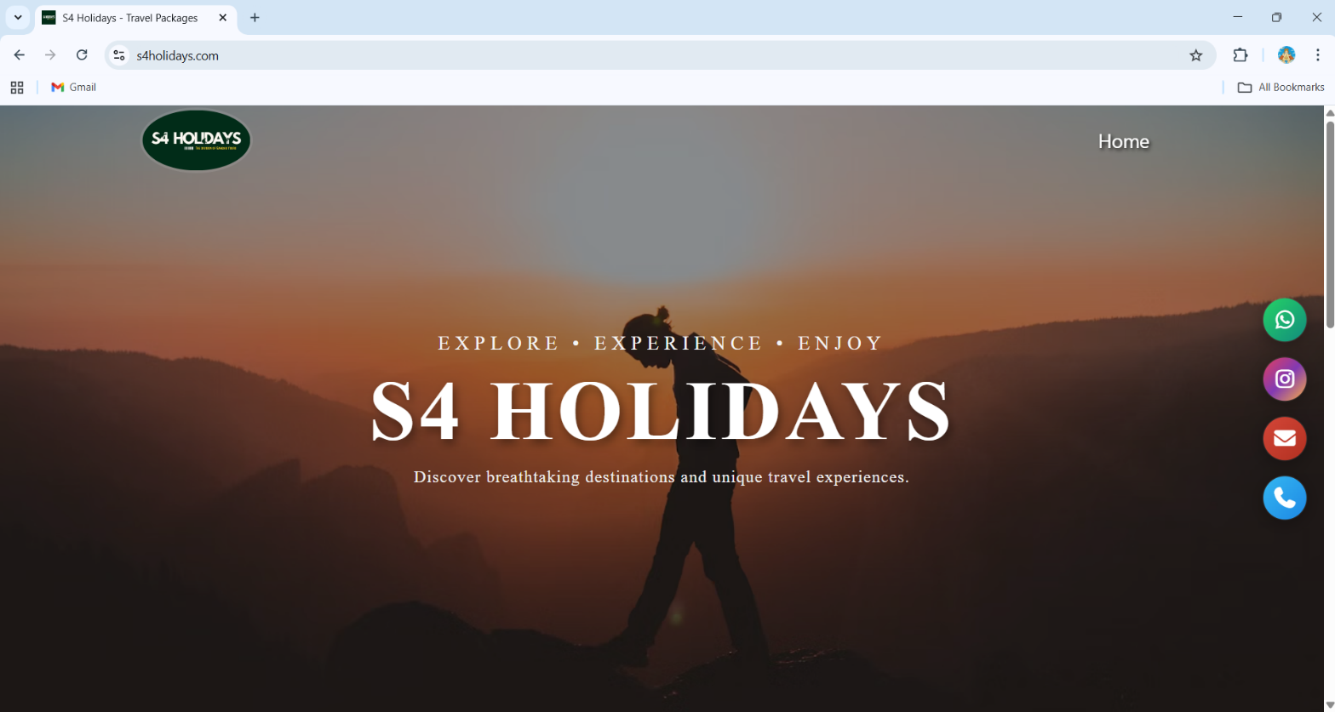\

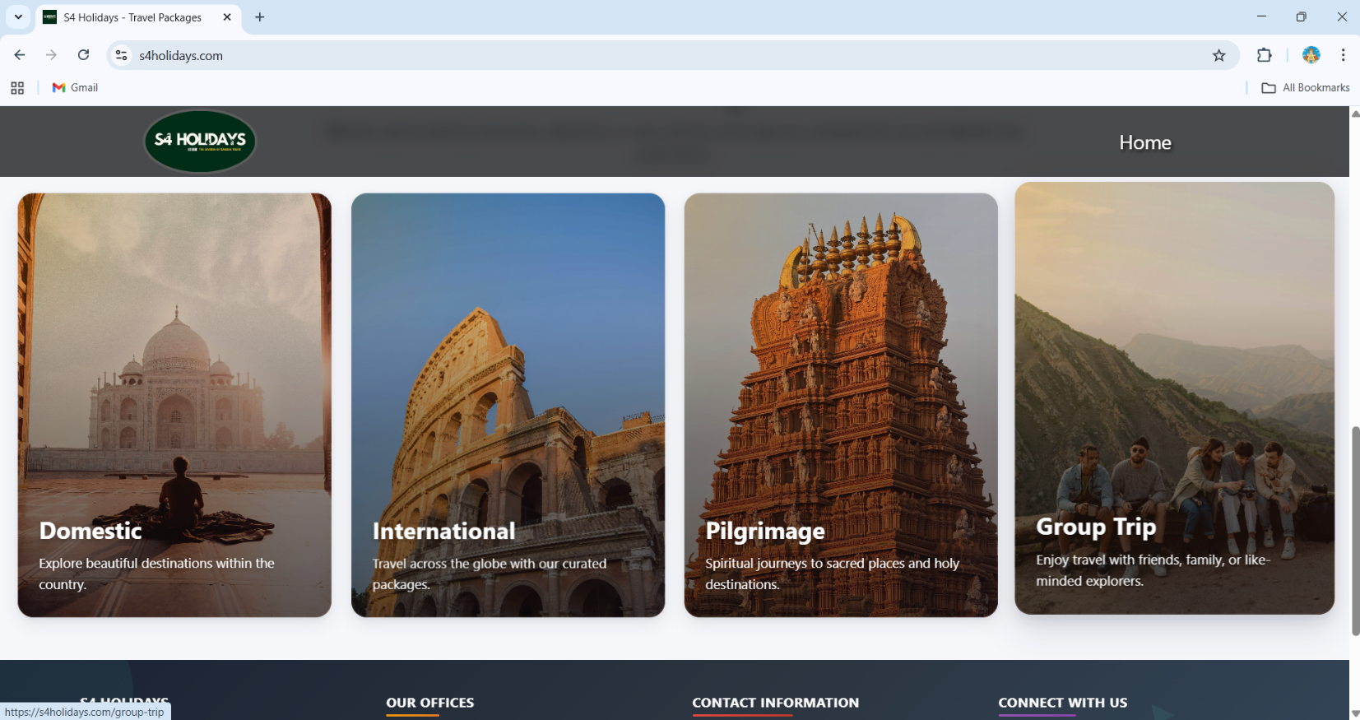

0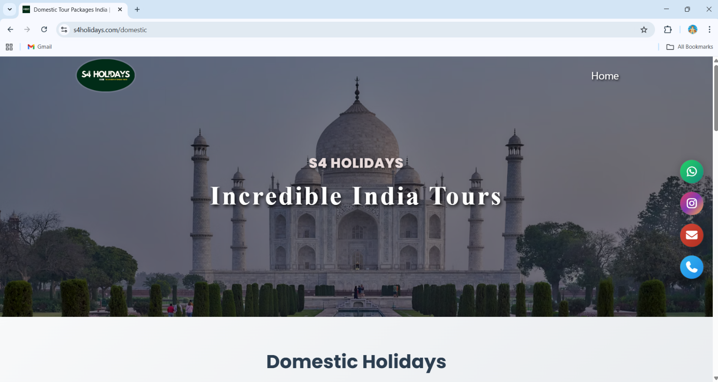

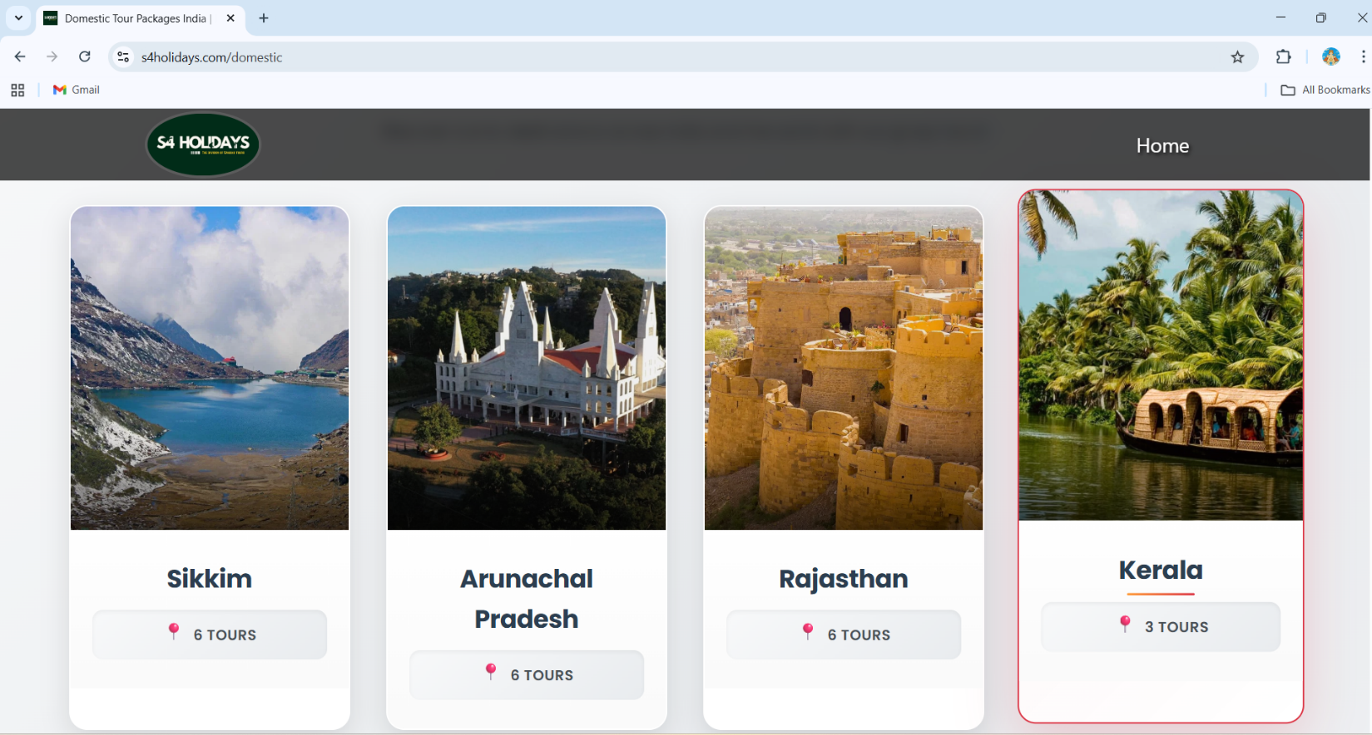

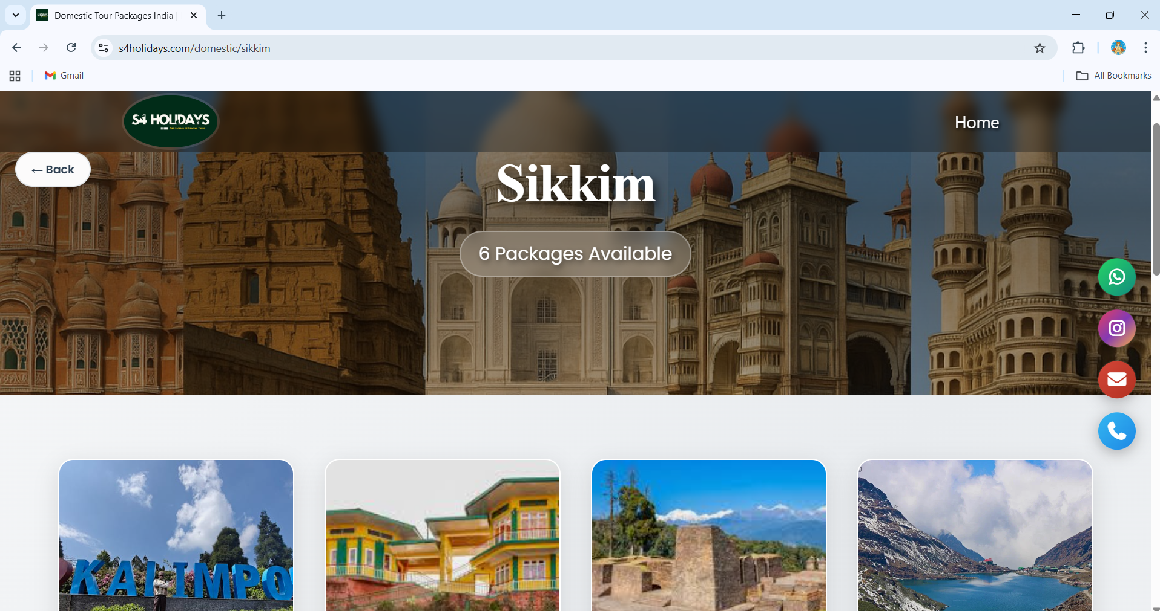

Admin :

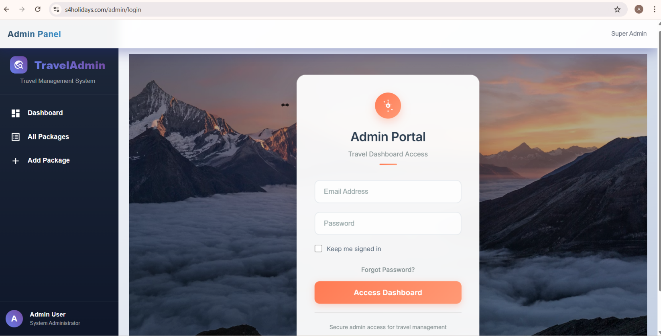
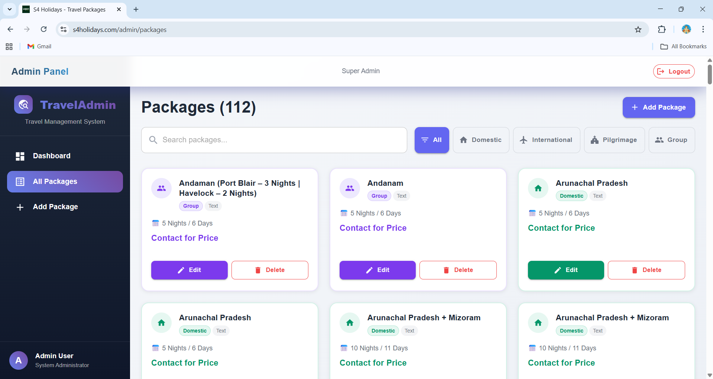
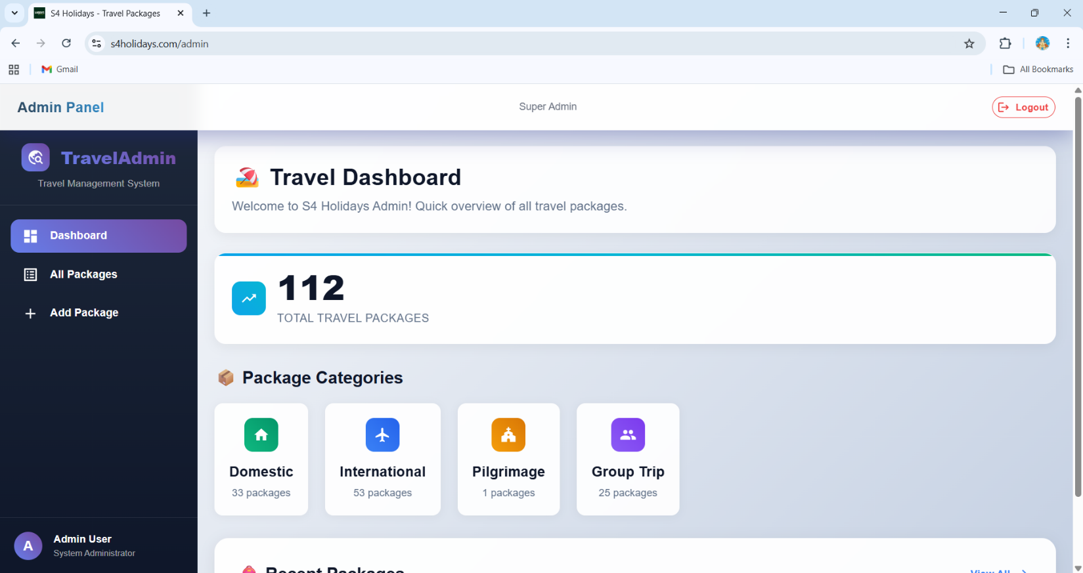
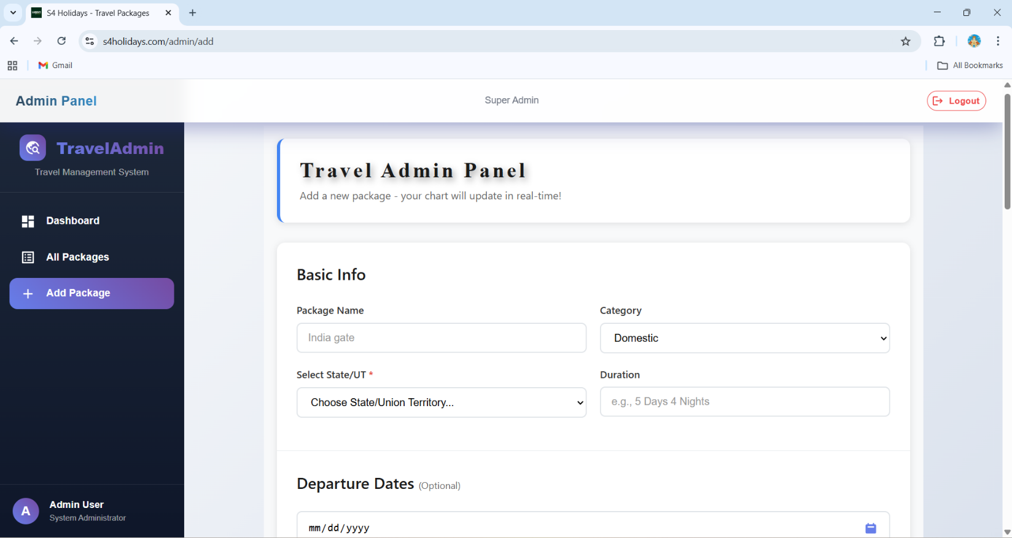

Conclusion
The S4 Holidays Tour and Travel Website was successfully designed and developed using modern web technologies under the MERN stack. The project aimed to provide a simple, efficient, and user-friendly platform for displaying travel packages and managing them through an admin panel. The system effectively meets the objectives defined at the beginning of the project.
The website allows users to view travel packages easily, while administrators can securely manage package information by adding, editing, and deleting content. The use of React with Vite ensures a responsive and dynamic user interface, Node.js handles backend operations efficiently, and MongoDB provides flexible and reliable data storage.
Through this project, the limitations of traditional manual travel service management are addressed by offering a structured and centralized digital solution. The project also helped the team gain practical experience in full-stack web development, teamwork, problem-solving, and real-world application design.
Overall, the S4 Holidays Tour and Travel Website serves as a functional and scalable solution for tour and travel management. The system can be further enhanced in the future by adding features such as online booking, payment integration, user authentication, and advanced admin controls, making it more comprehensive and robust.

